

**Course Title :** Database System Sessional

**Course Code : CCE -** 224

**Exercise on HR Database**

Patuakhali Science & Technology University

Dumki, Patuakhali - 8602

**Submitted By**

**Name :**

**Id :**

**Reg. No :**

**Session :**

Md Mohidul Alam

1902016

08722

2019 - 20

**Submitted To**

**Professor** **Dr. Md. Samsuzzaman**

Department of Computer and Communication Engineering

Faculty Of Computer Science & Engineering.

# Exercises on HR Database (w3 resources)

# MySQL Basic SELECT statement [19 Exercises]

1. Write a query to display the names (first_name, last_name) using alias name “First Name", "Last Name".

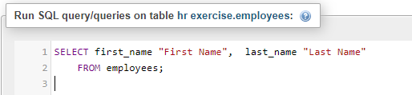

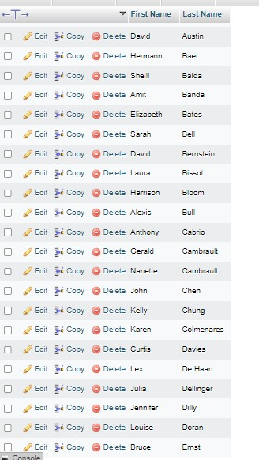

1. Write a query to get unique department ID from employee table.

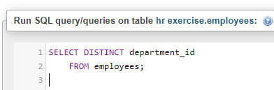

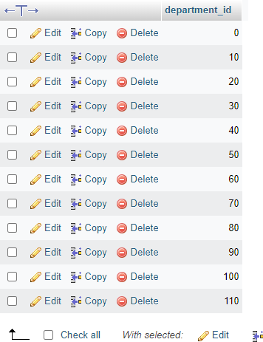

1. Write a query to get all employee details from the employee table order by first name, descending.

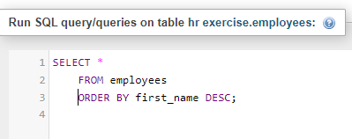

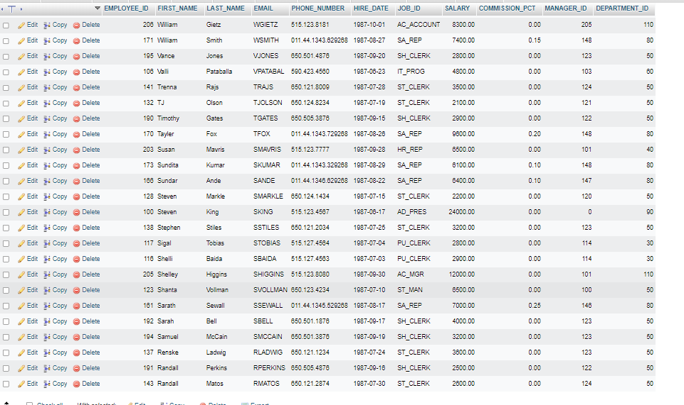

1. Write a query to get the names (first_name, last_name), salary, PF of all the employees (PF is calculated as 15% of salary).

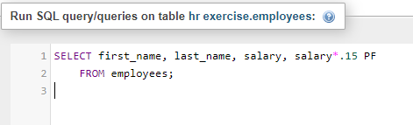

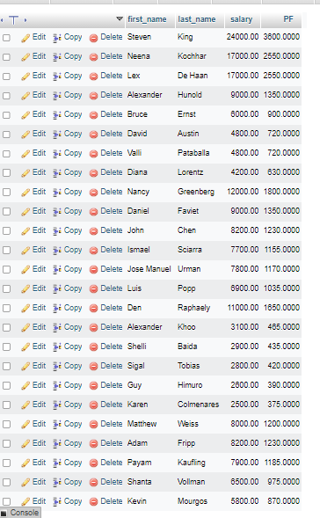

1. Write a query to get the employee ID, names (first_name, last_name), salary in ascending order of salary.

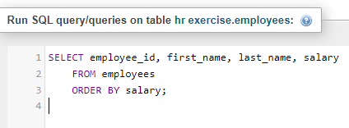

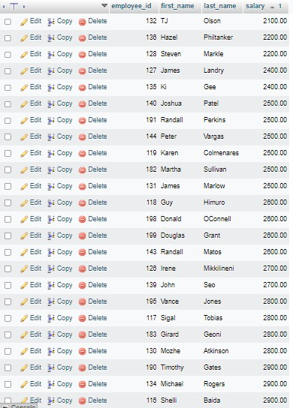

1. Write a query to get the total salaries payable to employees.

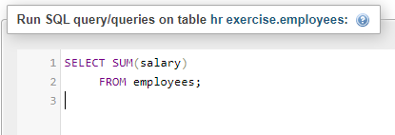



1. Write a query to get the maximum and minimum salary from employees table.

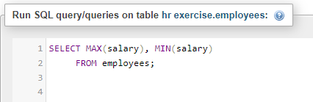

1. Write a query to get the average salary and number of employees in the employees table.

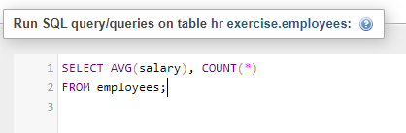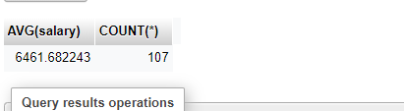

1. Write a query to get the number of employees working with the company.

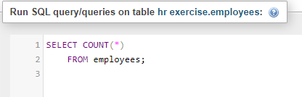



1. Write a query to get the number of jobs available in the employees table.

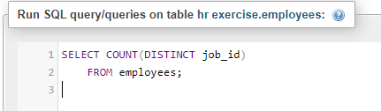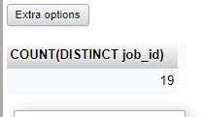

1. Write a query get all first name from employees table in upper case.

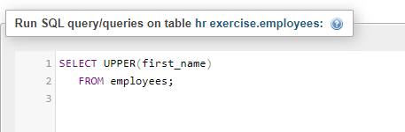

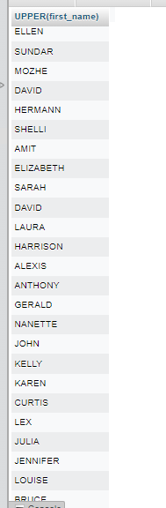

1. Write a query to get the first 3 characters of first name from employees table.

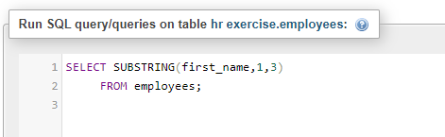

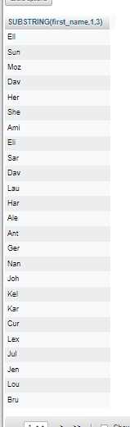

1. Write a query to calculate 171*214+625.

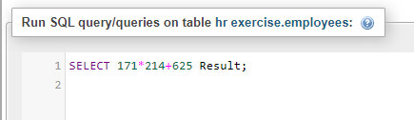

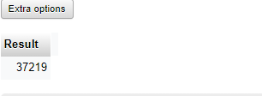

1. Write a query to get the names (for example Ellen Abel, Sundar Ande etc.) of all the employees from employees table.

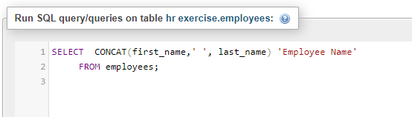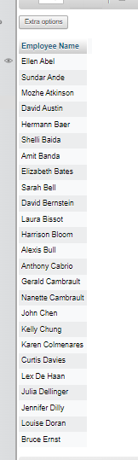

1. Write a query to get first name from employees table after removing white spaces from both side.

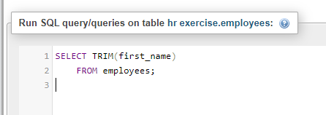

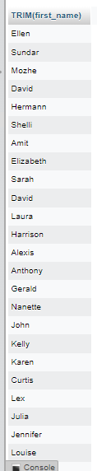

1. Write a query to get the length of the employee names (first_name, last_name) from employees table.

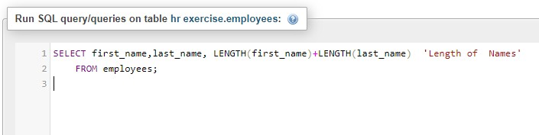

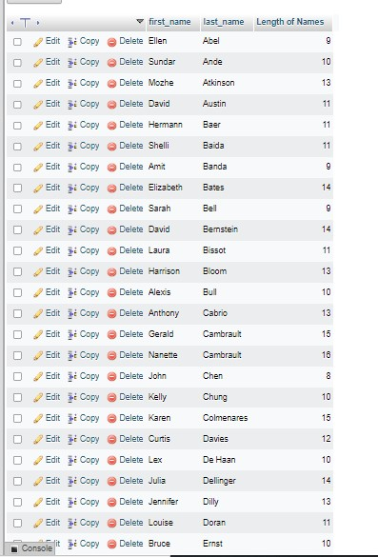

1. Write a query to check if the first_name fields of the employees table contains numbers.

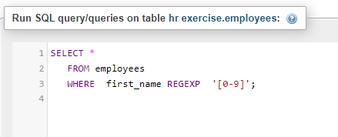

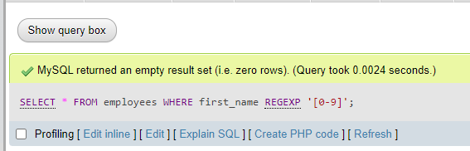

1. Write a query to select first 10 records from a table.

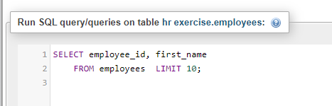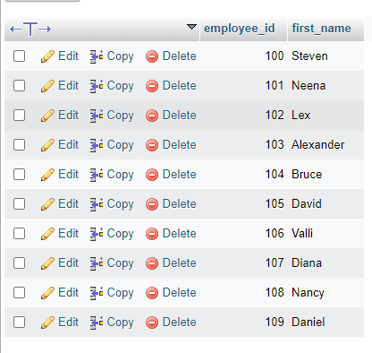

1. Write a query to get monthly salary (round 2 decimal places) of each and every employee.

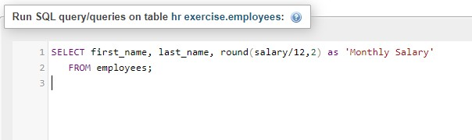

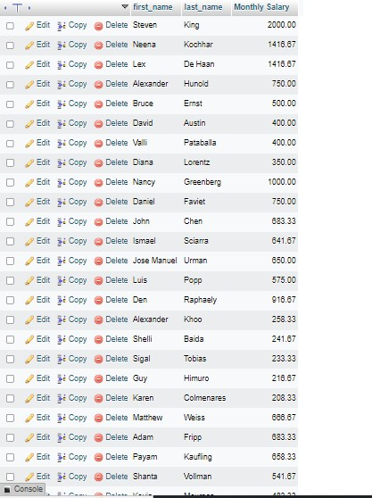

# MySQL Restricting and Sorting data: [11 exercises with solution]

1. Write a query to display the name (first_name, last_name) and salary for all employees whose salary is not in the range $10,000 through $15,000.

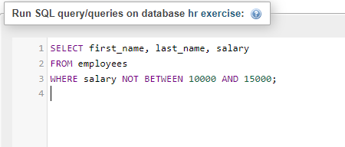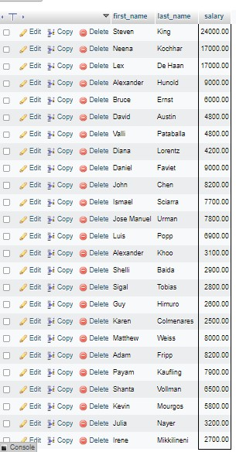

1. Write a query to display the name (first_name, last_name) and department ID of all employees in departments 30 or 100 in ascending order.

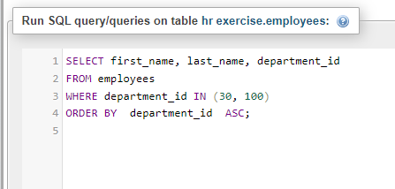

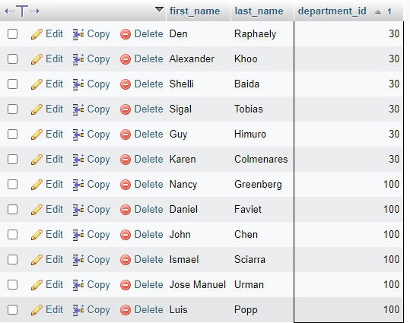

1. Write a query to display the name (first_name, last_name) and salary for all employees whose salary is not in the range $10,000 through $15,000 and are in department 30 or 100.

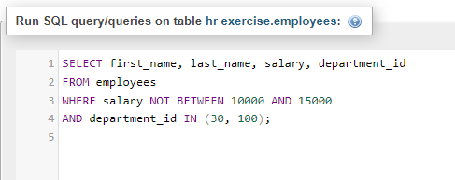

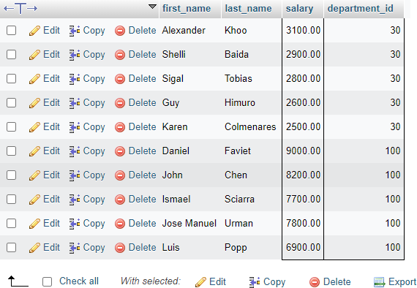

1. Write a query to display the name (first_name, last_name) and hire date for all employees who were hired in 1987.

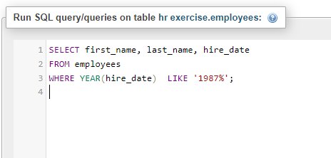

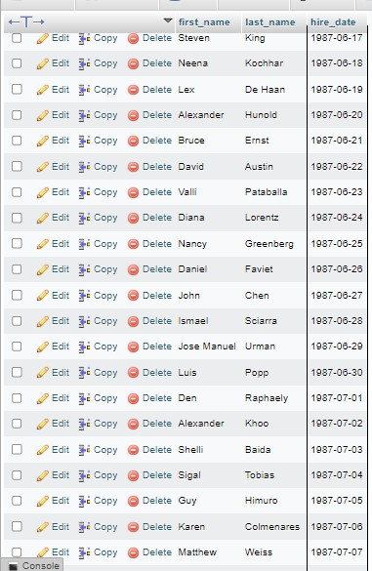

1. Write a query to display the first_name of all employees who have both "b" and "c" in their first name.

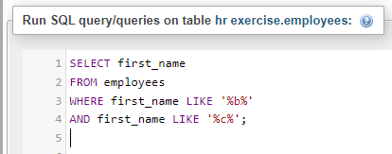

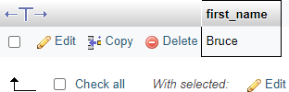

1. Write a query to display the last name, job, and salary for all employees whose job is that of a Programmer or a Shipping Clerk, and whose salary is not equal to $4,500, $10,000, or

$15,000.

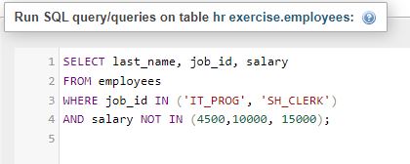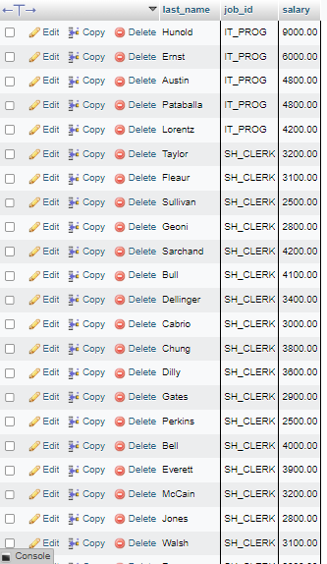

1. Write a query to display the last name of employees whose names have exactly 6 characters.

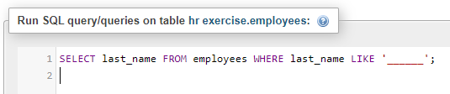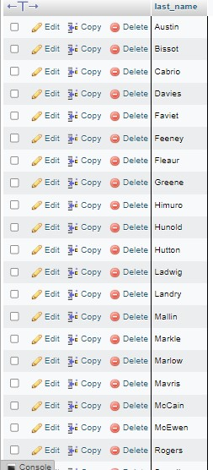

1. Write a query to display the last name of employees having 'e' as the third character.

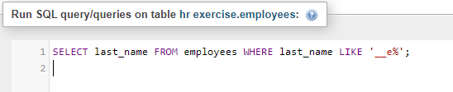

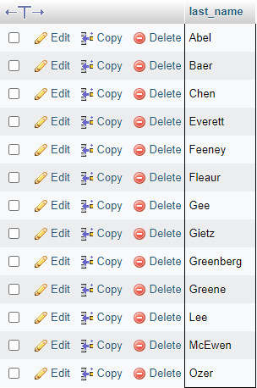

1. Write a query to display the jobs/designations available in the employees table.

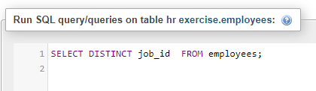

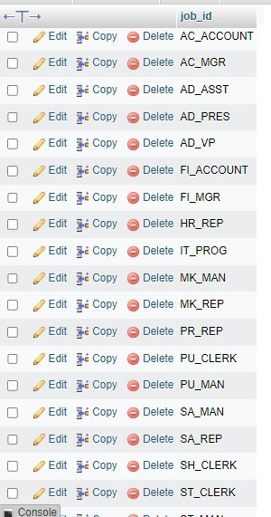

1. Write a query to display the name (first_name, last_name), salary and PF (15% of salary) of all employees.

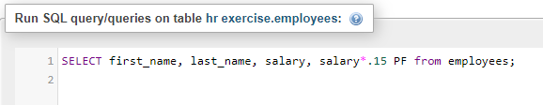

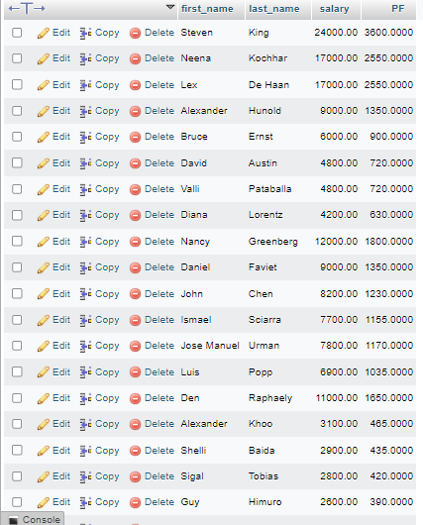

1. Write a query to select all record from employees where last name in 'BLAKE', 'SCOTT', 'KING' and 'FORD'.

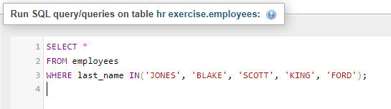

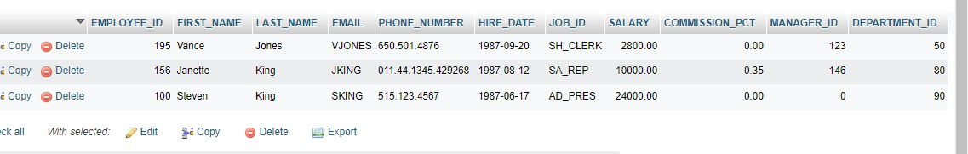

# MySQL Aggregate Functions and Group by [14 Exercises with Solutions]

1. Write a query to list the number of jobs available in the employees table.

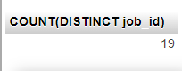

1. Write a query to get the total salaries payable to employees.

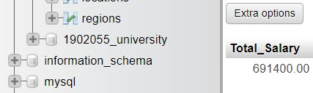

1. Write a query to get the minimum salary from employees table.

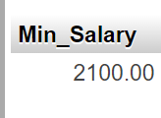

1. Write a query to get the maximum salary of an employee working as a Programmer.

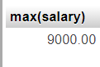

1. Write a query to get the average salary and number of employees working the department 90.

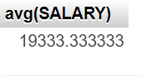

1. Write a query to get the highest, lowest, sum, and average salary of all employees.

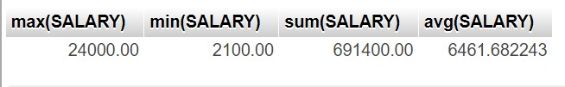

1. Write a query to get the number of employees with the same job.

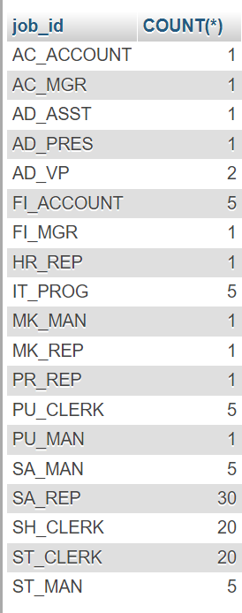

1. Write a query to get the difference between the highest and lowest salaries.

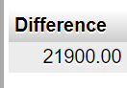

1. Write a query to find the manager ID and the salary of the lowest-paid employee for that manager.

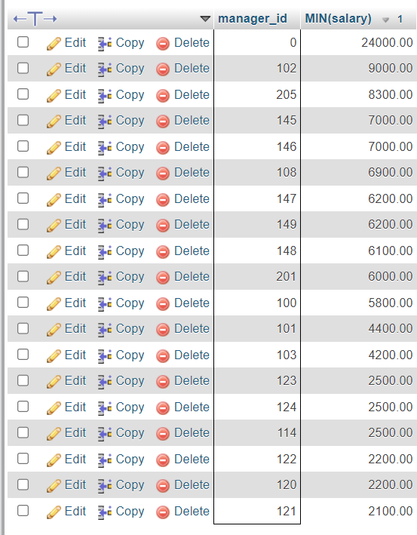

1. Write a query to get the department ID and the total salary payable in each department.

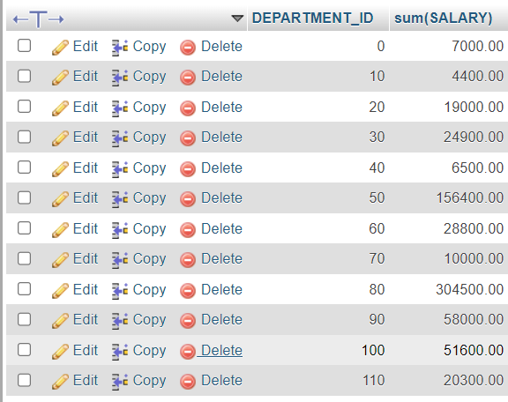

1. Write a query to get the average salary for each job ID excluding programmer.

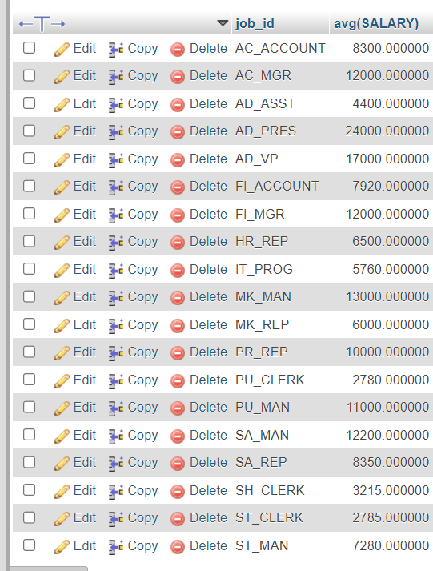

1. Write a query to get the total salary, maximum, minimum, average salary of employees (job ID wise), for department ID 90 only.

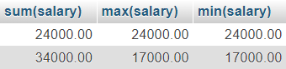

1. Write a query to get the job ID and maximum salary of the employees where maximum salary is greater than or equal to $4000.

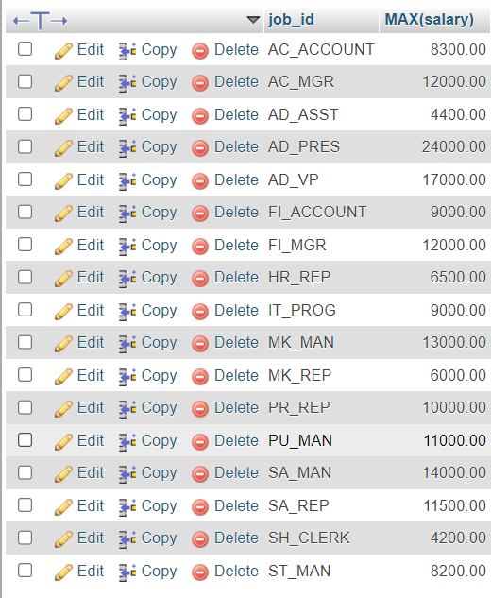

1. Write a query to get the average salary for all departments employing more than 10 employees.

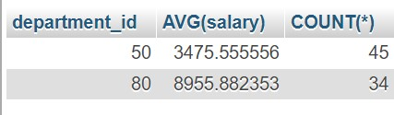

# MySQL Subqueries [22 Exercises with Solution ]

1. Find the name and salary of the employees who have a higher salary than the employee whose last_name='Bull'

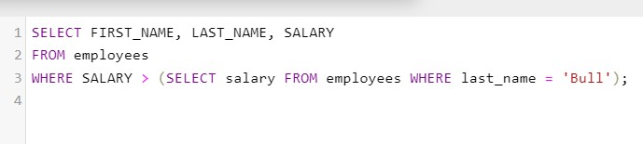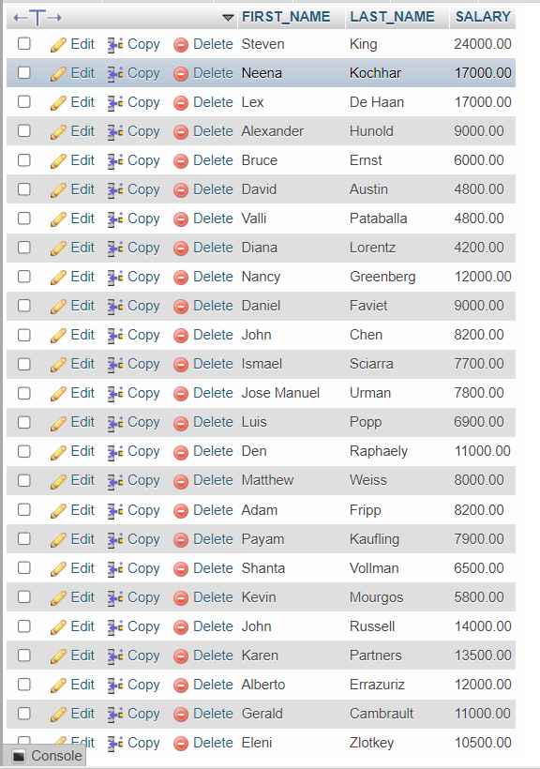

1. Write a query to find the name (first_name, last_name) of all employees who works in the IT department.

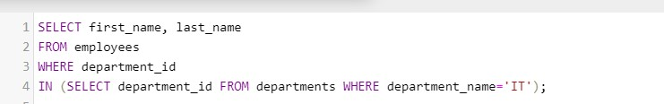

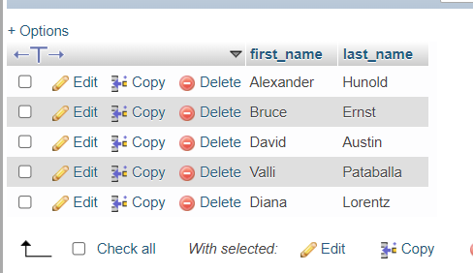

1. Write a query to find the name (first_name, last_name) of the employees who have a manager and worked in a USA based department.

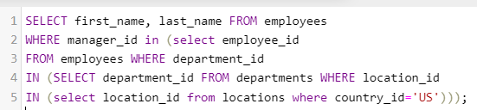

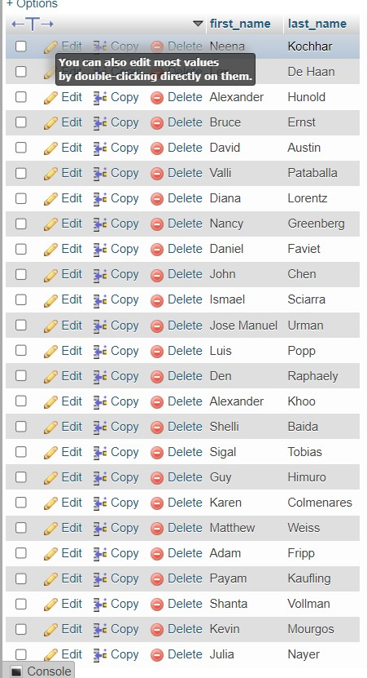

1. Write a query to find the name (first_name, last_name) of the employees who are managers.

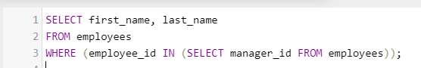

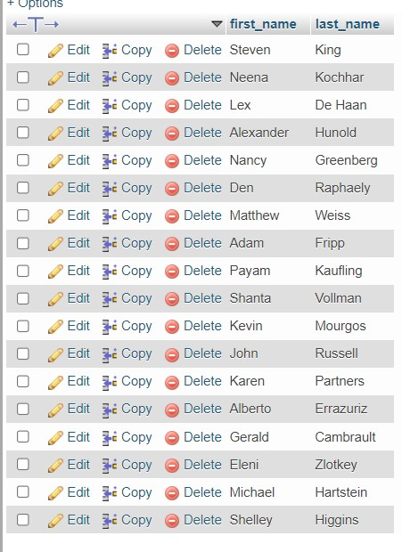

1. Write a query to find the name (first_name, last_name), and salary of the employees whose salary is greater than the average salary.

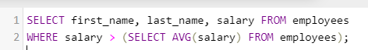

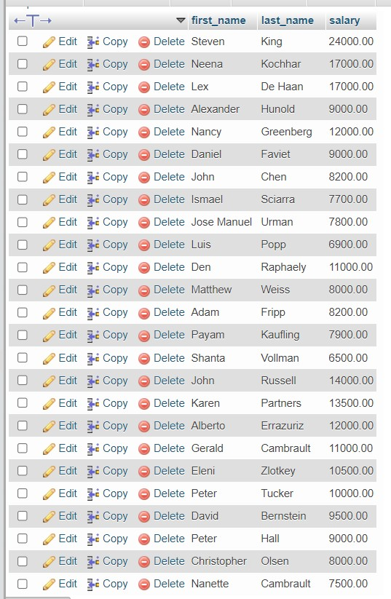

1. Write a query to find the name (first_name, last_name), and salary of the employees whose salary is equal to the minimum salary for their job grade.

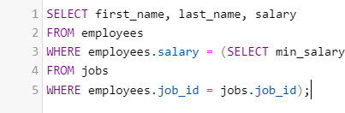

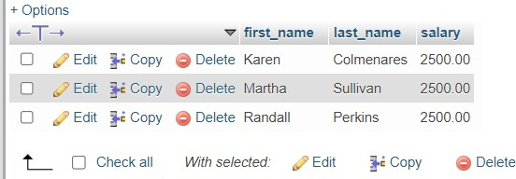

1. Write a query to find the name (first_name, last_name), and salary of the employees who earns more than the average salary and works in any of the IT departments.

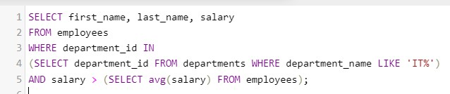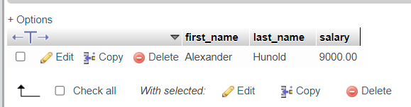

1. Write a query to find the name (first_name, last_name), and salary of the employees who earns more than the earning of Mr. Bell.

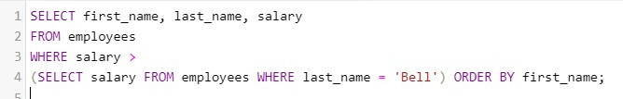

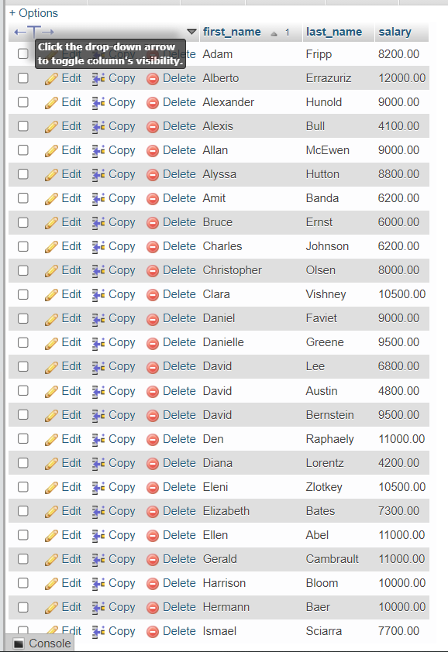

1. Write a query to find the name (first_name, last_name), and salary of the employees who earn the same salary as the minimum salary for all departments.

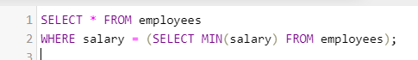



1. Write a query to find the name (first_name, last_name), and salary of the employees whose salary is greater than the average salary of all departments.

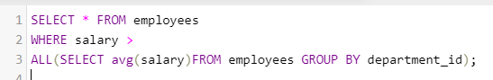

1. Write a query to find the name (first_name, last_name) and salary of the employees who earn a salary that is higher than the salary of all the Shipping Clerk (JOB_ID = 'SH_CLERK'). Sort the results of the salary of the lowest to highest.

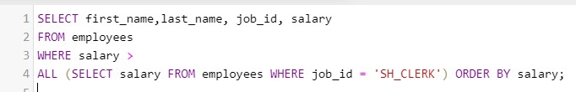

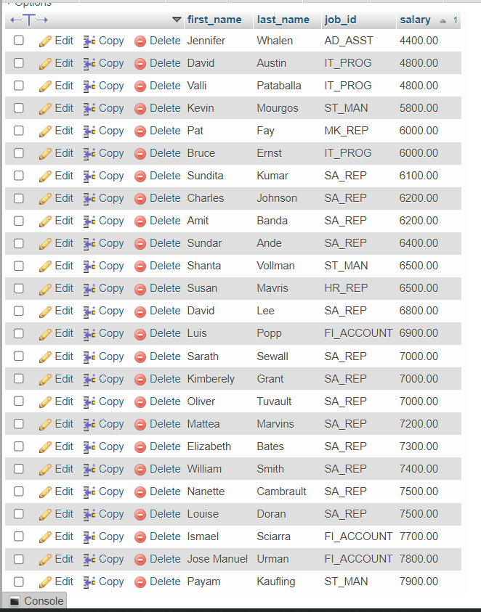

1. Write a query to find the name (first_name, last_name) of the employees who are not supervisors.

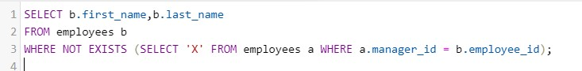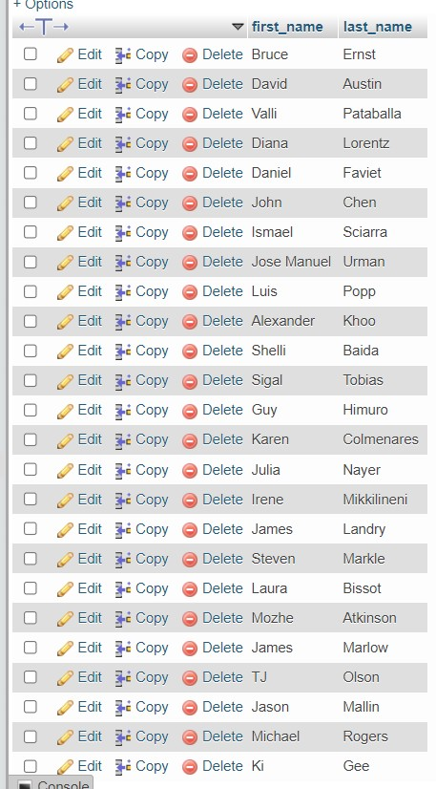

1. Write a query to display the employee ID, first name, last name, and department names of all employees.

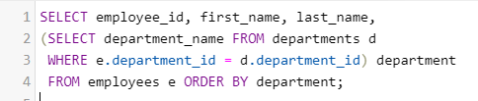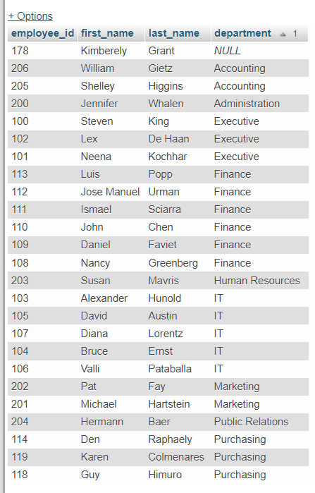

1. Write a query to display the employee ID, first name, last name, salary of all employees whose salary is above average for their departments.

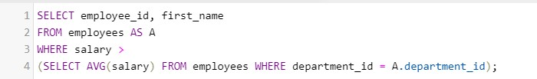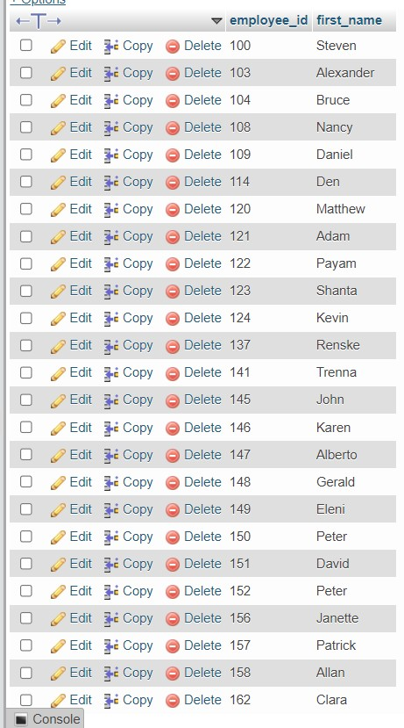

1. Write a query to fetch even numbered records from employees table.

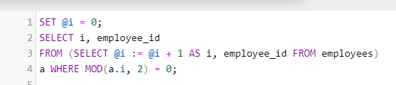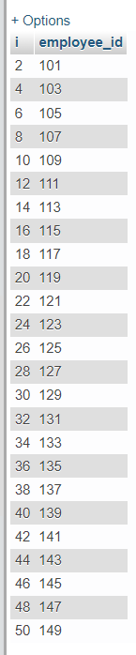

1. Write a query to find the 5th maximum salary in the employees table.

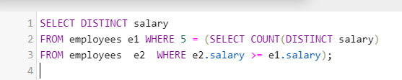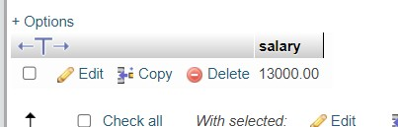

1. Write a query to find the 4th minimum salary in the employees table.

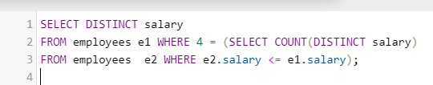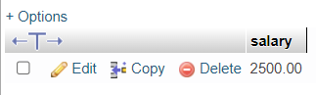

1. Write a query to select last 10 records from a table.

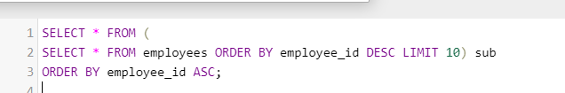

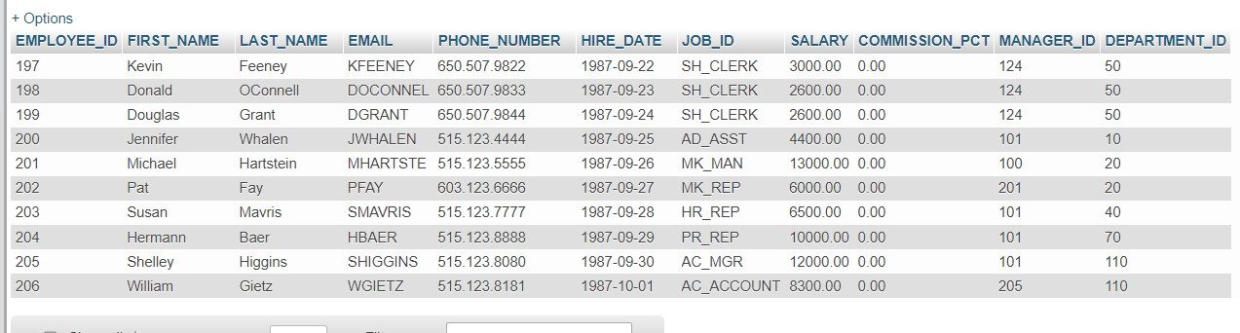

1. Write a query to list the department ID and name of all the departments where no employee is working.

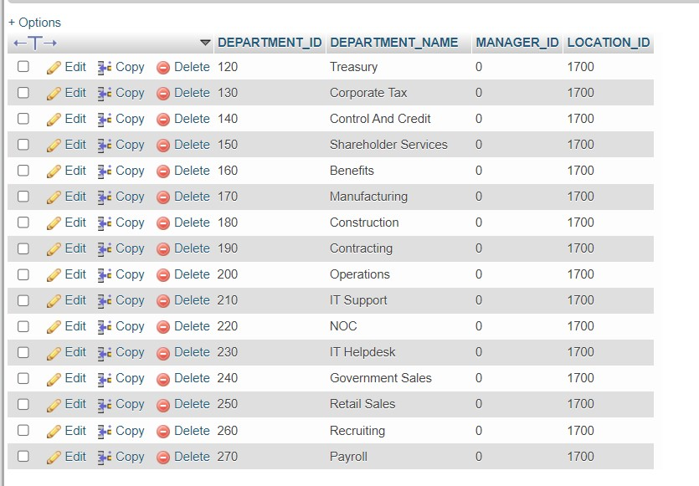

1. Write a query to get 3 maximum salaries.

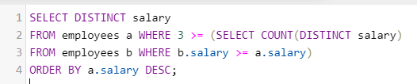

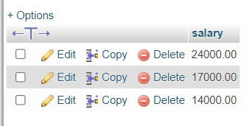

1. Write a query to get 3 minimum salaries.

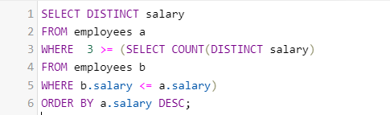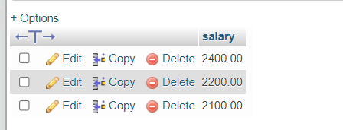

1. Write a query to get nth max salaries of employees.

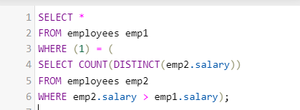

# MySQL JOINS [13 Exercises with Solution]

1. Write a query to find the addresses (location_id, street_address, city, state_province, country_name) of all the departments.

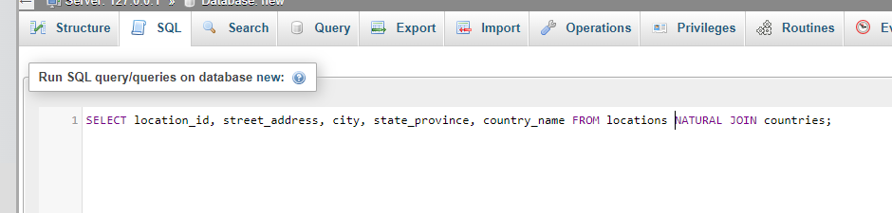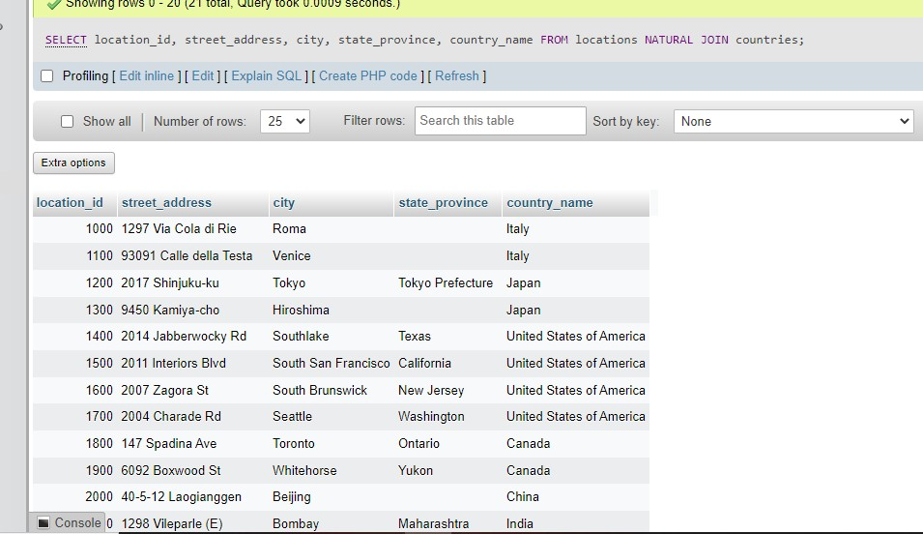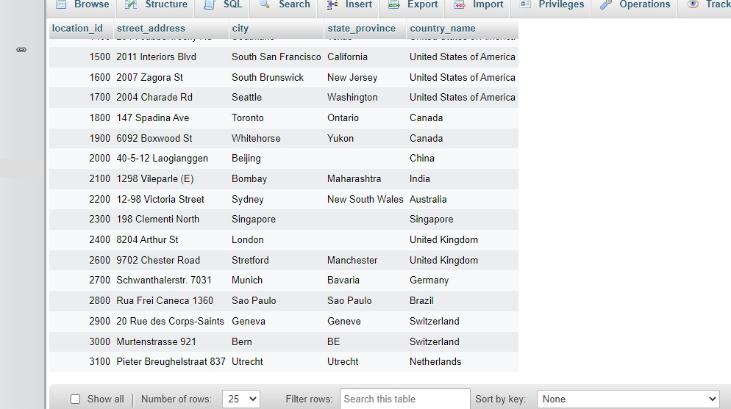

1. Write a query to find the name (first_name, last name), department ID and name of all the employees.

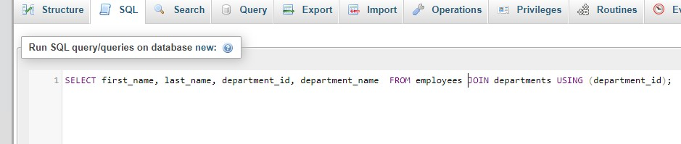

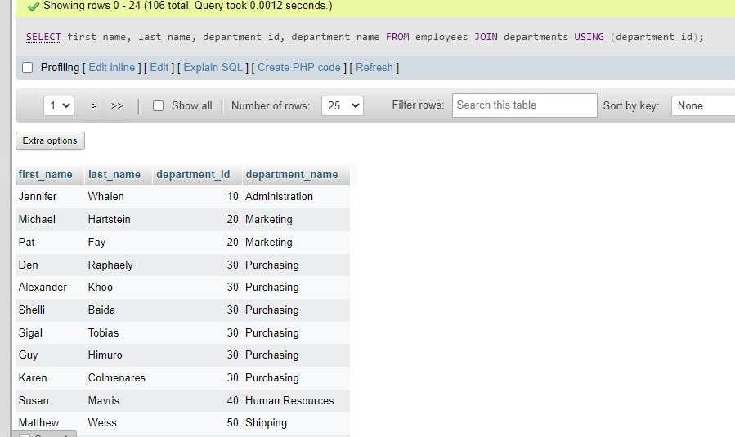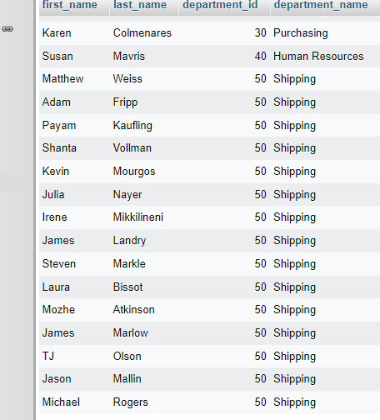

1. Write a query to find the name (first_name, last_name), job, department ID and name of the employees who works in London.

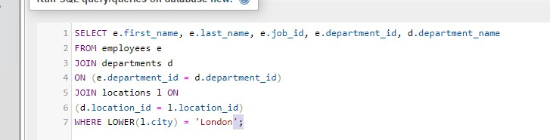

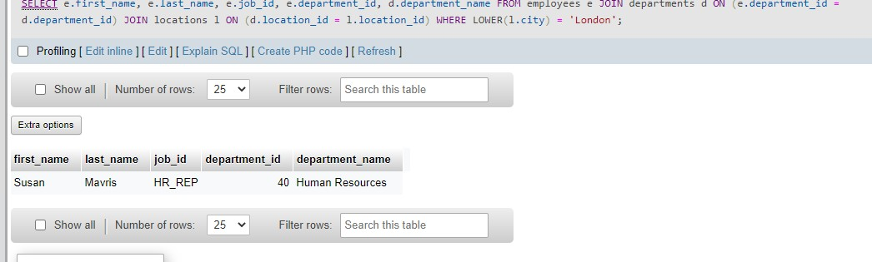

1. Write a query to find the employee id, name (last_name) along with their manager_id and name (last_name).

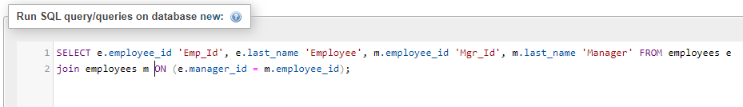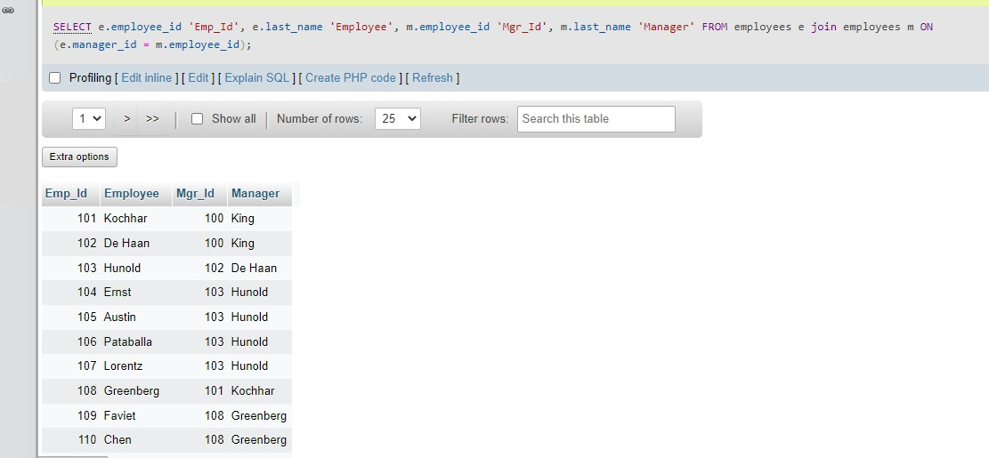

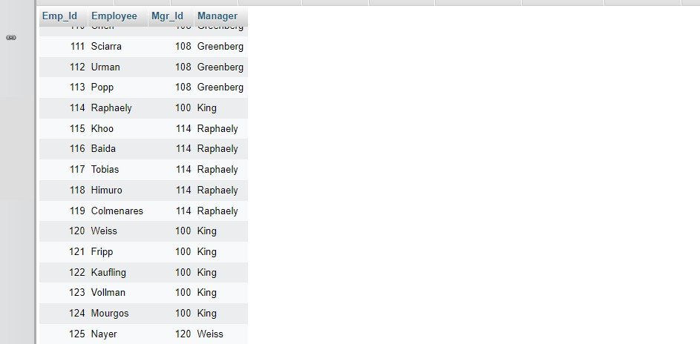

1. Write a query to find the name (first_name, last_name) and hire date of the employees who was hired after 'Jones'.

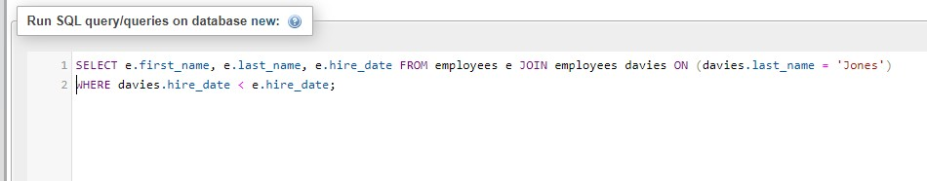

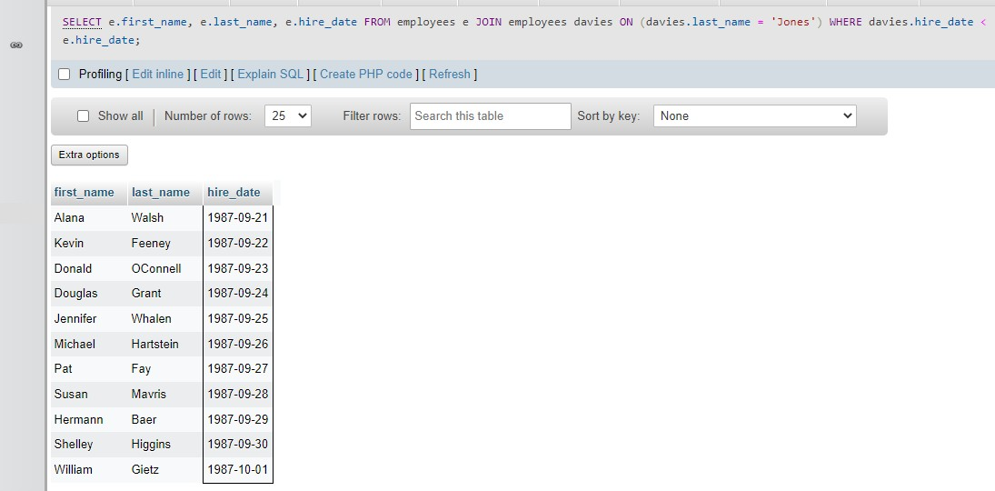

1. Write a query to get the department name and number of employees in the department.

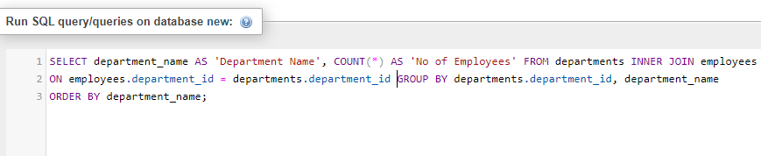

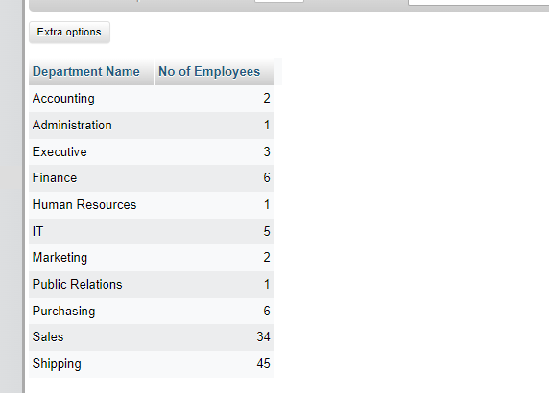

1. Write a query to find the employee ID, job title, number of days between ending date and starting date for all jobs in department 90.

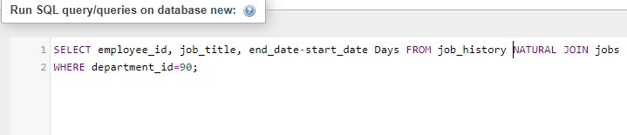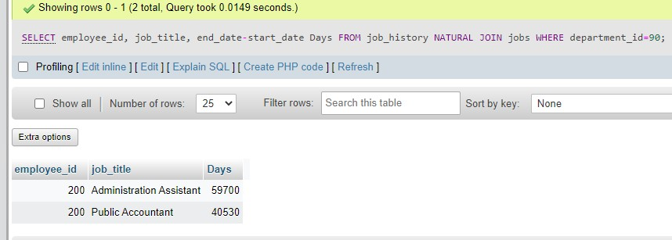

1. Write a query to display the department ID and name and first name of manager.

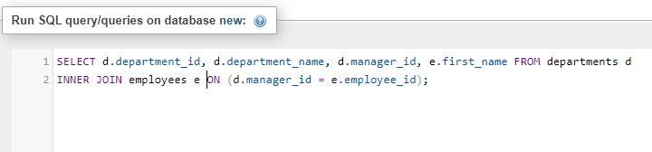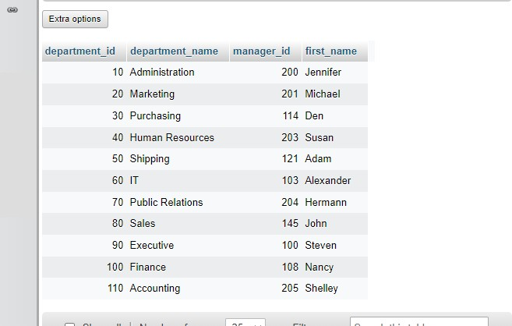

1. Write a query to display the department name, manager name, and city.

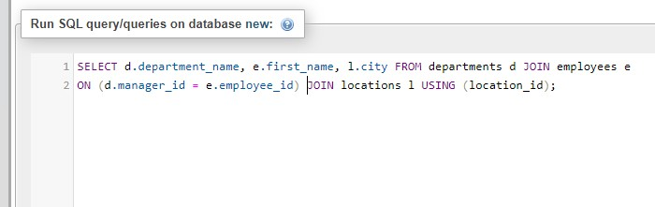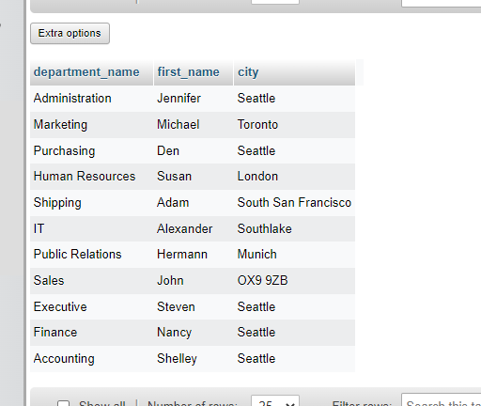

1. Write a query to display the job title and average salary of employees.

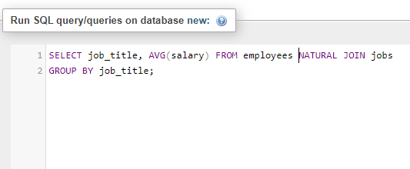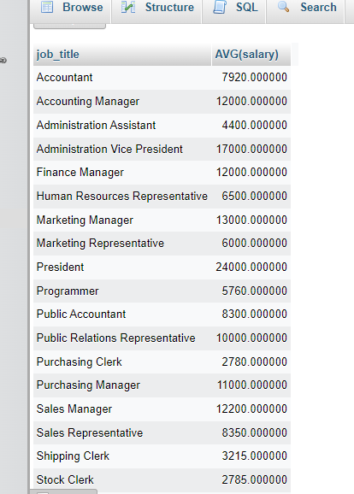

1. Write a query to display job title, employee name, and the difference between salary of the employee and minimum salary for the job.

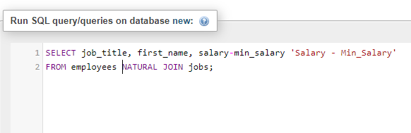

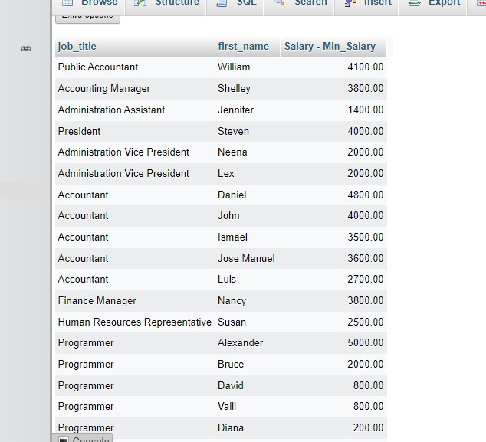

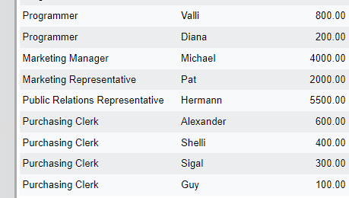

1. Write a query to display the job history that were done by any employee who is currently drawing more than 10000 of salary.

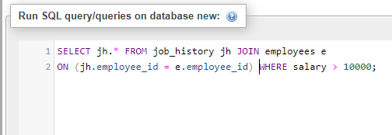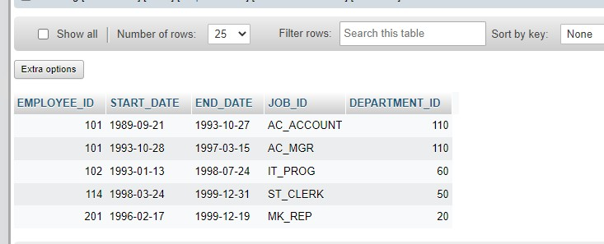

1. Write a query to display department name, name (first_name, last_name), hire date, salary of the manager for all managers whose experience is more than 15 years.

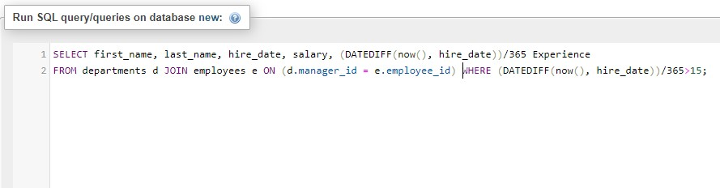

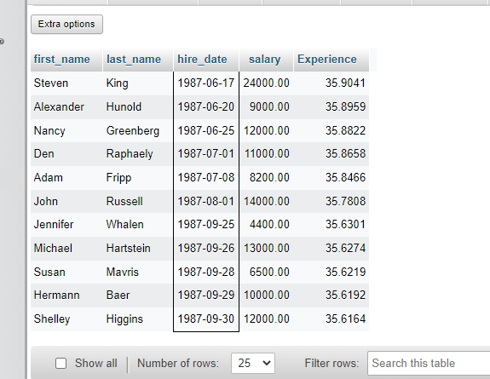

# MySQL String Functions [17 Exercises with Solution]

1. Write a query to get the job_id and related employee's id.

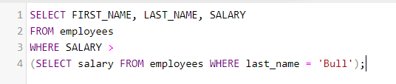

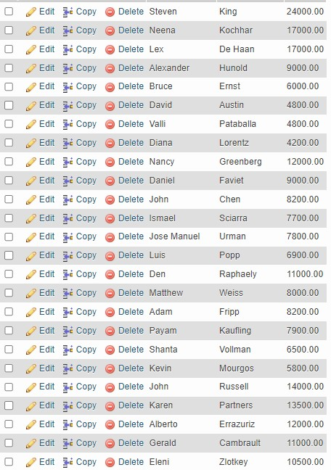

1. Write a query to update the portion of the phone_number in the employees table, within the phone number the substring '124' will be replaced by '999'.

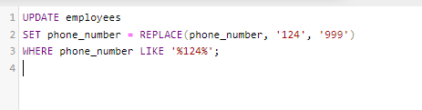



1. Write a query to get the details of the employees where the length of the first name greater than or equal to 8.

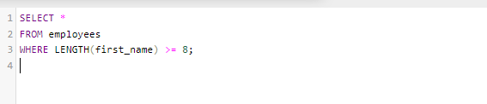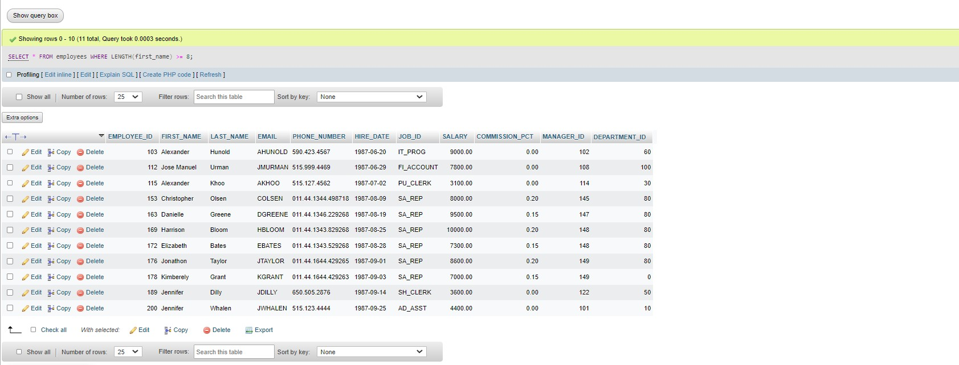

1. Write a query to display leading zeros before maximum and minimum salary.

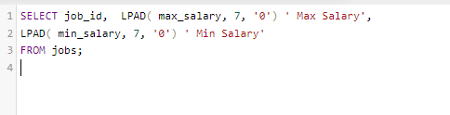

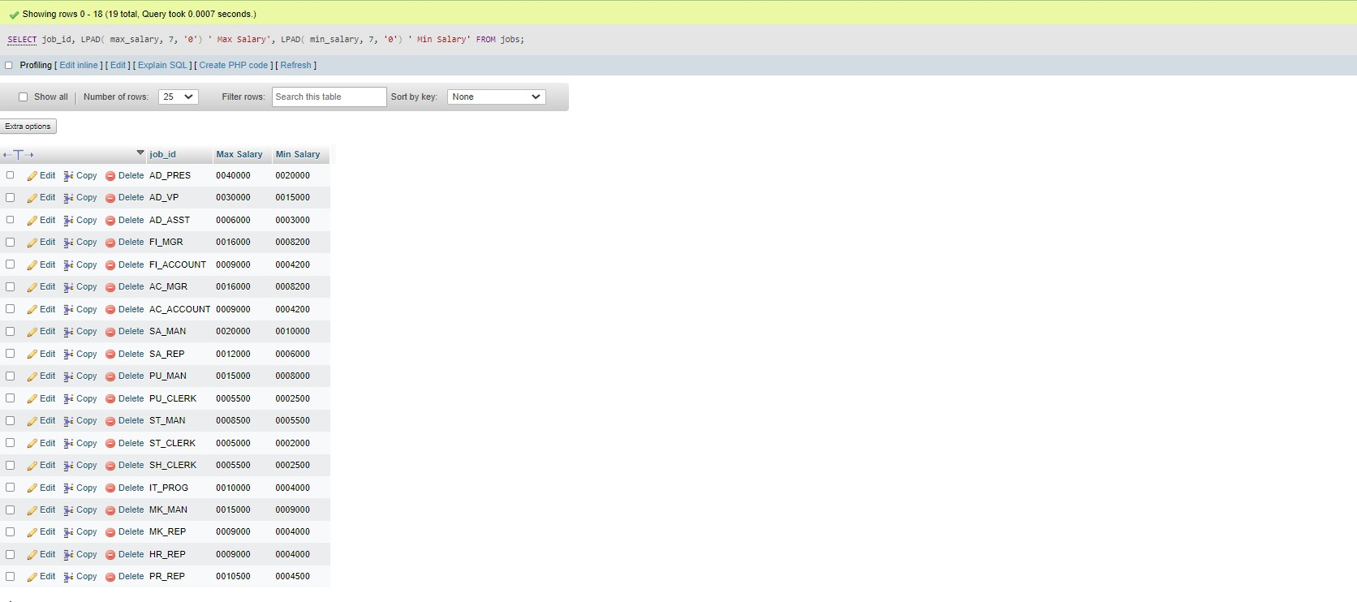

1. Write a query to append '@example.com' to email field.

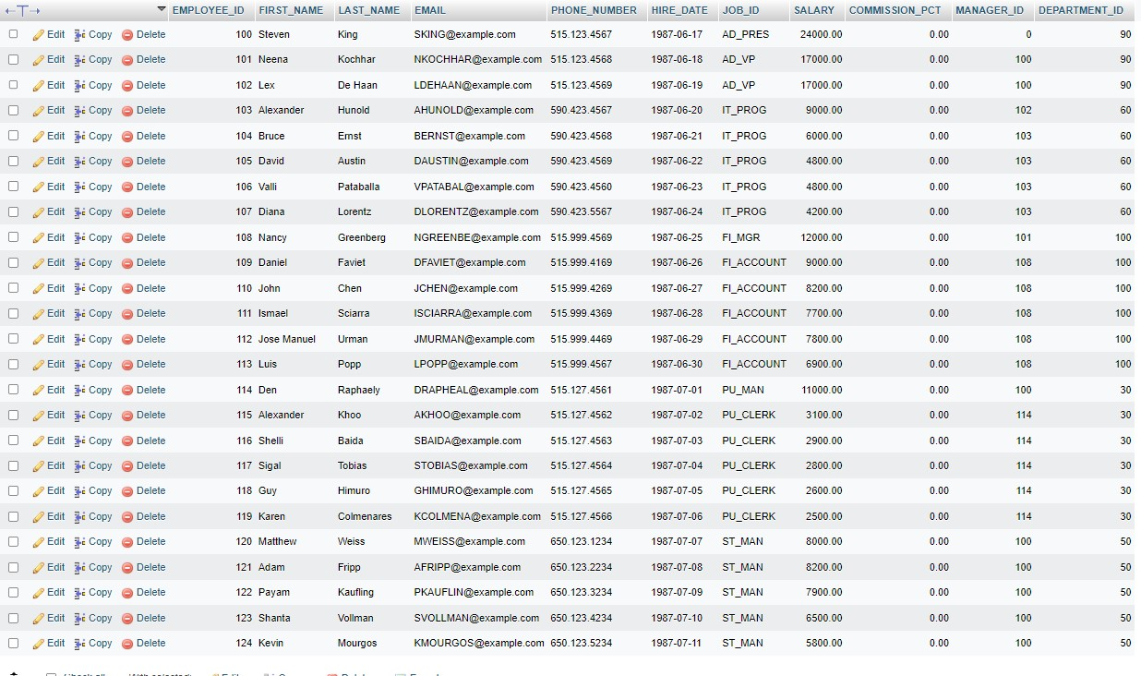

1. Write a query to get the employee id, first name and hire month.

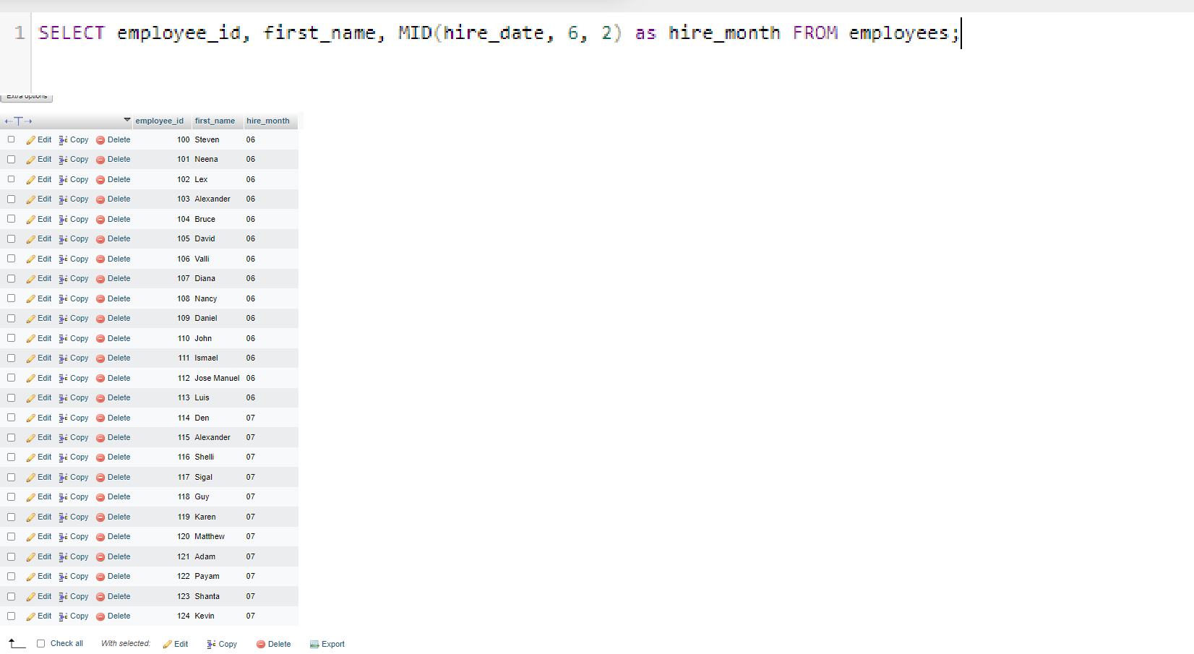

1. Write a query to get the employee id, email id (discard the last three characters).

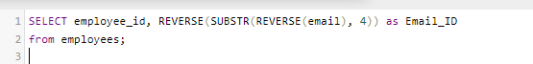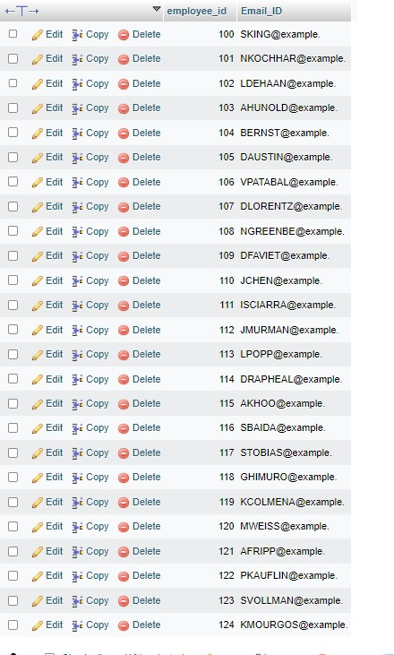

1. Write a query to find all employees where first names are in upper case.

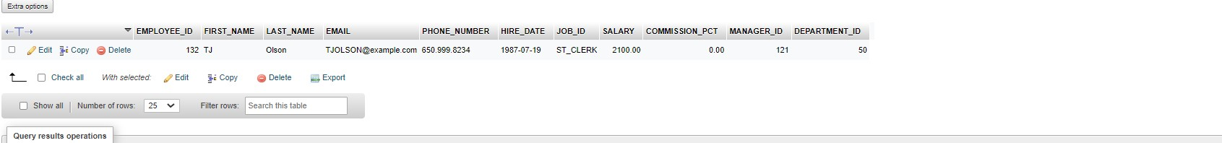

1. Write a query to extract the last 4 character of phone numbers.



1. Write a query to get the last word of the street address.

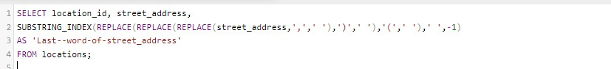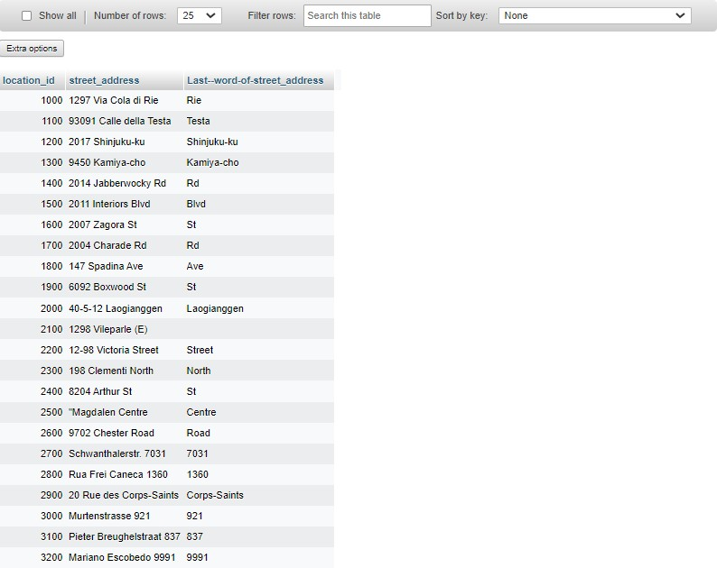

1. Write a query to get the locations that have minimum street length.

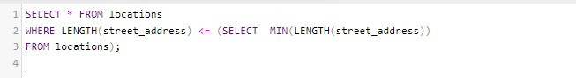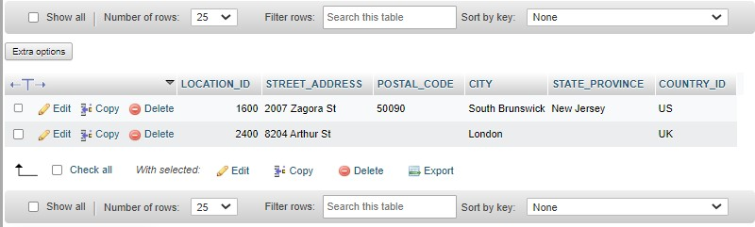

1. Write a query to display the first word from those job titles which contains more than one words.

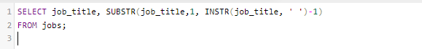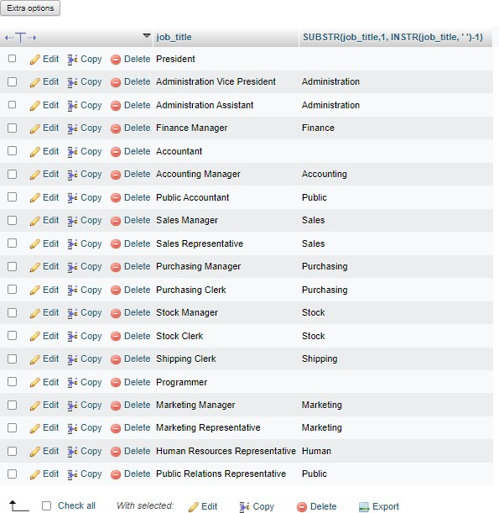

1. Write a query to display the length of first name for employees where last name contain character 'c' after 2nd position.

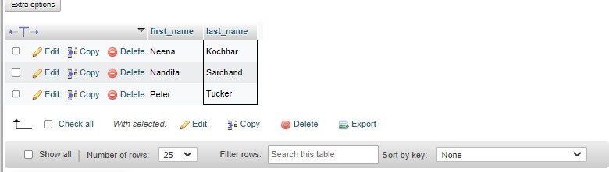

1. Write a query that displays the first name and the length of the first name for all employees whose name starts with the letters 'A', 'J' or 'M'. Give each column an appropriate label. Sort the results by the employees' first names.

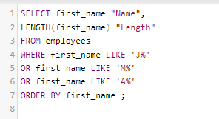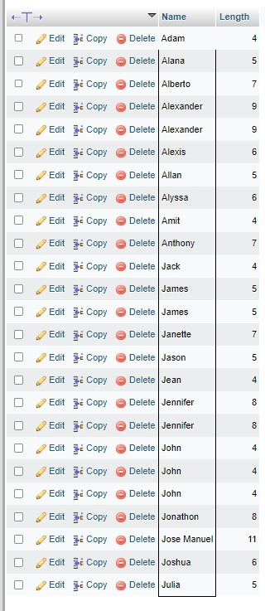

1. Write a query to display the first name and salary for all employees. Format the salary to be 10 characters long, left-padded with the $ symbol. Label the column SALARY.

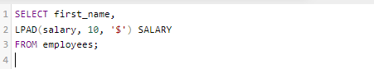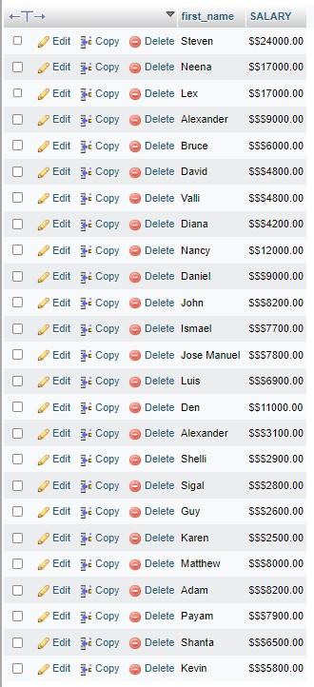

1. Write a query to display the first eight characters of the employees' first names and indicates the amounts of their salaries with '$' sign. Each '$' sign signifies a thousand dollars. Sort the data in descending order of salary.

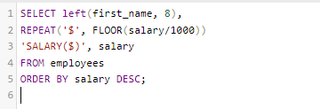

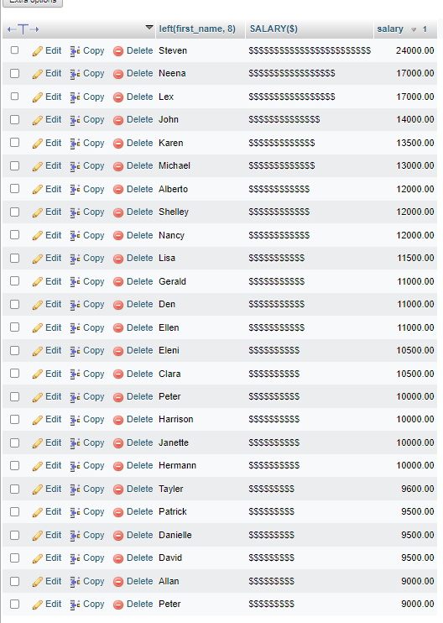

1. Write a query to display the employees with their code, first name, last name and hire date who hired either on seventh day of any month or seventh month in any year.

